

Mid-Year Project Report

SEDS

ME 755

8 December 2016

Reilly Webb (Team Leader)

Kevin Bucher

Nick Clegg

Faculty Advisor: Todd Gross

**Disclaimer**

This document is provided as part of the requirements of Mechanical Engineering course ME 755 & 756, at the University of New Hampshire. It does not constitute a professional engineering design document. Although the information is intended to be accurate, students, instructors, and the University of New Hampshire make no claims, promises, or guarantees about the accuracy, completeness, or adequacy of the information. The user of this document shall ensure that its use does not violate New Hampshire law with regard to professional licensing and certification requirements, including any work resulting from this student-prepared document required to be under the responsible charge of a licensed engineer.

**Table of Contents**

List of Figures.................................................................................................................................2

List of Tables.................................................................................................................................. 3

Introduction and Project Statement..................................................................................................4

Design Criteria and Required Standards..........................................................................................5

Alternative Solutions and Decision Matrices.................................................................................6

Project Schedule/Gantt Chart.........................................................................................................12

Analyses.........................................................................................................................................13

Summary........................................................................................................................................25

References......................................................................................................................................26

Appendix .......................................................................................................................................27

**List of Figures**

Figure 1: Experimental performance of nose cones from US missile research [5]......................11

Figure 2: Gantt Chart....................................................................................................................12

Figure 3: Figure 3: Schematic for Static test fire final design......................................................15

Figure 4: Estes E-9 Experimental and Theoretical response curves.............................................16

Figure 5: Estes E-9 Thrust response curves................................................................................. 17

Figure 6: Conical Mk 1 Rocket Design....................................................................................... 18

Figure 7: Multistage design that uses the Single Stage design as the second stage......................19

Figure 8: Phases of a rocket flight............................................................................................... 19

Figure 9: Drag coefficients for nose cone geometries................................................................. 21

Figure 10: Horizontally oriented static test fire rig..................................................................... 26

Figure 11: Vertically oriented static test fire system....................................................................27

Figure 12: static test fire prototype...............................................................................................27

**List of Tables**

Table 1: Engine decision matrix................................................................................................... 6

Table 2: Static Test Fire Decision Matrices................................................................................. 7

Table 3: Fuselage Decision Matrix............................................................................................... 9

Table 4: Stability values............................................................................................................... 24

**Introduction and Project Statement**

Students for the Exploration and Development of Space (SEDS) is a new club and senior design project at UNH. The UNH chapter consists of 25 students, most of which being underclassmen. The chapter will be competing in the Student rocketry competition offered through SEDS. SEDS is the largest student-run space organization in the world, consisting of an international community of high school, undergraduate and graduate students. SEDS offers many projects including the student rocketry competition. The goal of the project is to successfully design, build and launch a two-stage, solid-propellant rocket with a standardized altimeter to the highest possible altitude. The rocket is to be a sounding rocket, meaning the rocket will be sub orbital. Teams are scored on design, engineering and manufacturing as well as flight of the rocket. In order to complete the project, our chapter will have 4 main groups; Aero/Rocket body, engine, Static Test Fire and Launch pad. Aero/Rocket body, Static Test fire and engine will be acutely analyzed for the purpose of this paper. The competition consists of three engineering reports submitted to SEDS-USA. The first will focus on the design of the rocket, the second is a preflight report submitted after the rocket is built, the third is a post flight report discussing the results of launch. Final launch date for the competition is October 13th, 2018.

**Design Criteria and Required Standards**

* Rocket must be multistage
* All rocket parts must be recoverable and reusable
* Rocket must be large enough to house 29 mm engine
* Rocket must fit 15.7mm x 14mm altimeter.
* Altimeter must not detach from the rocket at any point
* No specialty launch systems allowed (e.g. rockets launched from balloons)
* Rocket must exceed 3000 feet in altitude
* .0002 times the recorded elevation will be subtracted to account for altitude effects
* Total combined impulse of all engines must not exceed 640 Newton-Seconds
* Launches must abide by local, state, and federal laws and regulations

**Alternative Solutions and Decision Matrices**

**Engine**

Figure 1 is the decision matrix used to decide on engine propellant type.

Table 1: Engine decision matrix

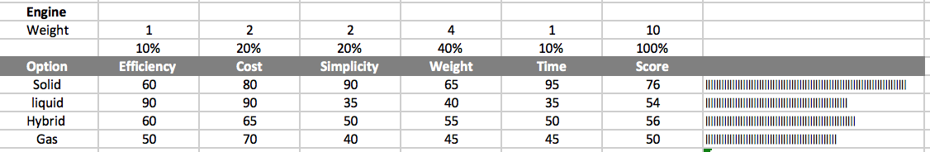

For our engine, we considered four engine types: solid, liquid, hybrid, and gas. The solid engine contains solid propellants; a mixture of fuel and oxidizer. Liquid engines contain stored fuel and stored oxidizer which are pumped into a combustion chamber where they are mixed and burned. Gas engines use compressed gas as a propellant, and hybrid engines mix solid fuel and a liquid/gas oxidizer.

We chose efficiency, cost, simplicity, weight, and time as our weighing criteria. Weight was the most important of the five criteria, as we want the lightest rocket design we can achieve. The efficiency of the engine type is not a huge concern since the rocket is being launched into the air and immediately deploying a parachute upon entering free-fall. Efficiency becomes a major concern when the rocket needs to enter orbit or is in flight for extended periods of time. We have several months to complete the final design so time also carried a low weight. Cost and simplicity are equally important categories since not only are we very limited in funds, but we want to go with an easier design for our first year to assure that we make our rocket fly. Provide a description of the reasoning undertaken in the determination of the weighting of the criteria.

Solid propellants are easy to store and easy to handle, and once purchased they are the easiest to install. This gave them the highest weight for simplicity and time. Liquid propellants are often cheaper than solid ones, yet they involve addition chambers and fuel lines that greatly increase the complexity and time it would take to design the engine assembly. Gas and hybrid fuels involve similar degrees of complexity. Gas engines include a heavy pressure vessel that would add too much weight to our rocket. The additional chambers and fuel lines of hybrid and liquid engines would all add to the overall weight of these alternatives as well. Liquid propellant engines are the most efficient, and as a result are typically used in orbital applications. Ultimately, a solid propellant engine type was chosen for our rocket as it was a lighter, simpler, and a more cost-effective option.

**Static Test Fire**

The static test fire rig is used for the sole reason of obtaining a Thrust vs. Time curve. This is useful as it allows the team to calculate total impulse as well as gives a good idea how the rocket will be accelerating throughout flight.

*Table 2: Static Test Fire Decision Matrices*



For the static test fire rig, we considered two different options: Vertical System and Horizontal system. A stand system is used for smaller engines and tend to be in an upright position with the engine thrust ejected upwards applying a force downward. A horizontal system is used for medium to large engines and is oriented so the engine applies thrust horizontally.

The team chose manufacturing, functionality, safety, cost and time as our weighing criteria. Manufacturing is weighted the heaviest due to limited machinability skills as well as access to high end equipment. Cost is weighed second highest since we have a small budget and need to spend sparingly. Functionality is tied for third as the rig must work as well as produce accurate results. Safety is of high concern because the engines are powerful and can cause harm in the case of a malfunction. Time is not of huge concern as we have approximately 12 months to complete the project, however, it must be taken into account.

The horizontal oriented system tends to be used for medium to large engines because the configuration supports the engine throughout the length of the body, rather than at the ends, allowing for more stability for bigger engines. Large Companies like NASA orient static test fires horizontally due to the massive size of their engines. The horizontal system requires more intense design, because there needs to be a robust backing so the force from the engine does not compromise the structural integrity of the system, making it expensive and hard to manufacture. The horizontal rig is just as functional as any other rig, with error mainly coming from the engine not being exactly horizontally oriented.

Vertical oriented systems are used for smaller engines because the engine is supported on its end, allowing for less stability for larger engines. It requires less complex design as it is not supporting the length of the engine, making it cheaper and easier to manufacture. The accuracy will be of no concern if the rocket is oriented perfectly perpendicular to the ground. Since the nature of the project will consist of smaller rockets and smaller engines, the vertical rig is advantageous for the competition.

**Aero/Rocket Body**

Table 3 displays the decision matrix for the material of the fuselage.

Table 3: Fuselage Decision Matrix

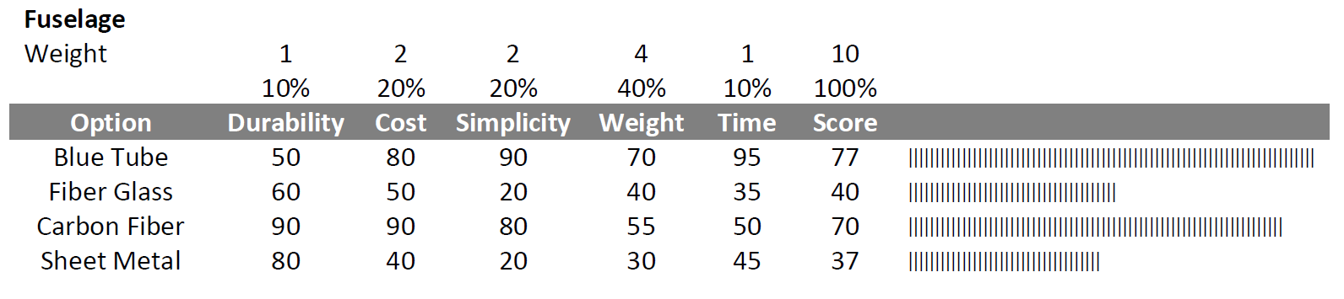

A primary design consideration for the rocket is the material used for the fuselage. This material will be a shell of the body of the rocket, and contribute significantly to the total mass of the rocket. This is why weight (density) is the highest weighted category.

Blue tube is a phenolic material that is extremely common for rockets of this scale. Fiber glass is a common type of fiber-reinforced plastic. Carbon fiber is a higher end material composed of fibers of carbon atoms. Aluminum sheet metal could also be rolled into a tube to create a durable shell.

Manufacturing time has a relatively low weight as we have months to complete a small sized rocket. The durability of the fuselage is not heavily weighted, as there is a relatively little stress on the material in typical flight scenarios. Cost and simplicity are important categories since not only are we very limited in funds, but we want to go with an easier design for our first year to assure that we make our rocket fly. The simpler the design, the less opportunity there is for mechanisms to go wrong. Time correlates with ease of manufacturing and the amount of engineering hours required to implement the design.

Blue tube may not be as durable as some of the other materials, however it is simple and cheap to purchase and assemble. It is also the least dense Page 3 of 3 material (.98 g/m^3), making it the lightest option for the geometry that we design. Carbon fiber is the most durable material, and we have a sponsor that is willing to make components out of carbon fiber for free. This sponsorship is not considered in the decision matrix. This makes it the lowest cost, however it is not nearly as light as the Blue Tube with a density of 1.55 g/m^3. Fiber glass and sheet metal would be manufactured in-house, taking up engineering time and opportunities for error. They are also denser and more expensive than the Blue Tube and carbon fiber. Blue Tube is the best option, primarily due to its low weight and simplicity, with carbon fiber being the next best option.

The nose cone component of the original rocket design was an optimized Von Karman nose cone. The geometry for this nose cone is a function of the radius and diameter of the rocket and is considered to have the lowest drag coefficient for rocket applications, as seen in the left most shape in Figure 9.

Once we began the manufacturing process, we realized that creating the Von Karman shaped form to wrap the carbon fiber would be impossible without the use of a CNC lathe. Since the UNH machine shop only has manual lathes, a simple conical geometry was selected for the nose cone. A conical shape has poor performance during the speed range that we are expecting, as seen in the experimental data in Figure 1, but this difference is predicted to be insignificant.

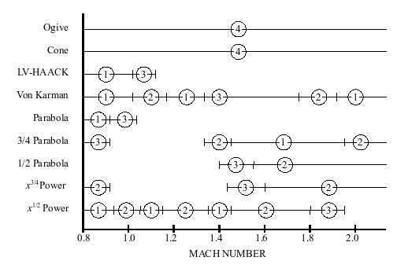

Figure 1: Experimental performance of nose cones from US missile research [5]

**Project Schedule/Gantt Chart**

Figure 2, below, is an overview of the schedule for our project. It has been updated as the team has progressed with the project throughout the semester.

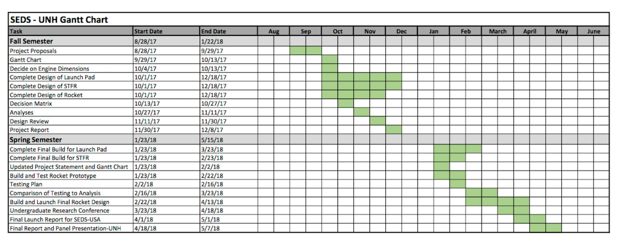

*Figure 2: Gantt Chart*

As seen above in Figure 2, design of the static test fire rig (STFR), launch pad, and rocket are all completed. A prototype of the STFR has been complete and results for a smaller-scale rocket engine can be seen in Figure x. During J term, group members will not be around, and construction will be on hold. The final STFR design will be manufactured in the first few weeks of Spring 2018. The launch pad is awaiting assembly as well, which is planned for the first month of the following semester. Once these preliminary fixtures are complete, rocket assembly can begin for the final design. Future deadlines for each semester are also highlighted for both ME 755 and SEDS USA.

**Analysis**

**Engine**

Once propellant type was decided upon, engine size became the next concern. Nearly all other aspects of the project depended on the length and diameter of the engines used. Store-bought engines come in standard diameters. *Apogee Rockets* lists 13, 18, 24, 29, 38, and 54 mm diameters. Because of the limitations set on total combined impulse, 54 mm rocket engines could not be considered as even the lowest impulse choice exceeded 640 N-s. 13, 18, and 24 mm engines had impulses that were far too low to even be an option. The decision came down to 29 mm or 38 mm. With two engines of this diameter, a combined impulse of just below 640 N-s can be achieved. Achieving the highest possible altitude will require the least amount of air resistance on the rocket and lowest weight, coupled with the highest engine impulse. Numerous other factors are important as well, but are not relevant to engine optimization. To account for this, the smaller diameter engine was chosen. With the addition of an engine housing and carbon fiber body tube, the final diameter of the rocket will be about 31 mm. Each engine measures about a foot in length, and will account for the majority of the weight of the rocket. Containing the engine securely within the body tube requires the use of a durable, reloadable casing. Unlike some engine housings, this casing is reusable and will allow for multiple launches. A threaded cap was designed to allow for easy assembly and disassembly of the rocket engine.

Several engines were purchased for the design and analysis. The final dual-stage rocket will use two engines, and the prototype being built this semester will use a single, full size engine. To test the static test fire rig, three small-scale Estes engines were purchased as well.

**Static Test Fire**

The test fire rig design will first be used for an E9-6 24 mm solid rocket engine. After the design is understood to be safe and accurate, larger engines more suited for our rocket will be tested. Knowing a range of thrust our engine will produce, we can then implement the required gauge to calculate thrust. The team will be using a 100 lb load cell for an approximated 40 N of thrust. There are many benefits to a load cell, primarily they are very accurate and can require no calibration, and setup and implementation is easy. However, calibration will be done to ensure the load cell is accurate. To obtain thrust we will need to understand the inner workings of the load cell. The load cell consists of 4 strain gauges in a wheatstone bridge configuration. Two of the strain gauges are in tension while the other two are in compression creating a change in resistance that produces a change in voltage output. Our goal is to convert the given voltage to thrust using a given sensitivity.

The force that the engine will apply on the load cell will be expressed as *F = ma*. Where F is force, m is the mass of the motor, and a is the acceleration of the motor. The output given by the load cell will be in voltage and can be converted to force. The resulting thrust response will be found as a function of time. The sensitivity is 3.4 mV/V at full scale. With an excitation voltage of 10 V we will receive 34 mV output for a 250 lb input, and using an amplifier with a gain of 100 the final output will be 3.4 V. We will find that there is .0136 V per pound of force. Using this relation we can convert the voltage output to thrust. After calculating thrust, the impulse of the rocket engine can also be found by the relationship: *Impulse* = *Thrust* x *Time.*

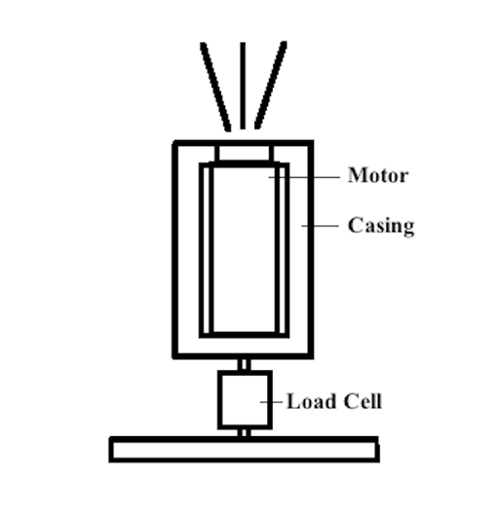

*Figure 3: Schematic for Static test fire final design*

The final static test fire setup is seen in Figure 3. The rocket motor will be tightly secured inside of a cylindrical casing that will have an inside diameter of 54 mm. The test fire rig will be used for testing various motor diameters for multiple rocket projects. For our first analysis, an Estes E-9 24 mm motor will be analyzed. This smaller scale experiment will ensure that the process of recording data is sufficient before testing higher-thrust engines. The load cell will screw into both the steel base plate and steel casing assembly. On the final design, set screws may be utilized to provide tighter motor fitment and discourage movement inside the casing. The engine will ignite, expel exhaust gases upwards, and result in a downward force on the load cell. In conjunction with Virtual Bench, the load cell will record voltage and time data.

The following response was captured by the load cell for the E-9 motor.

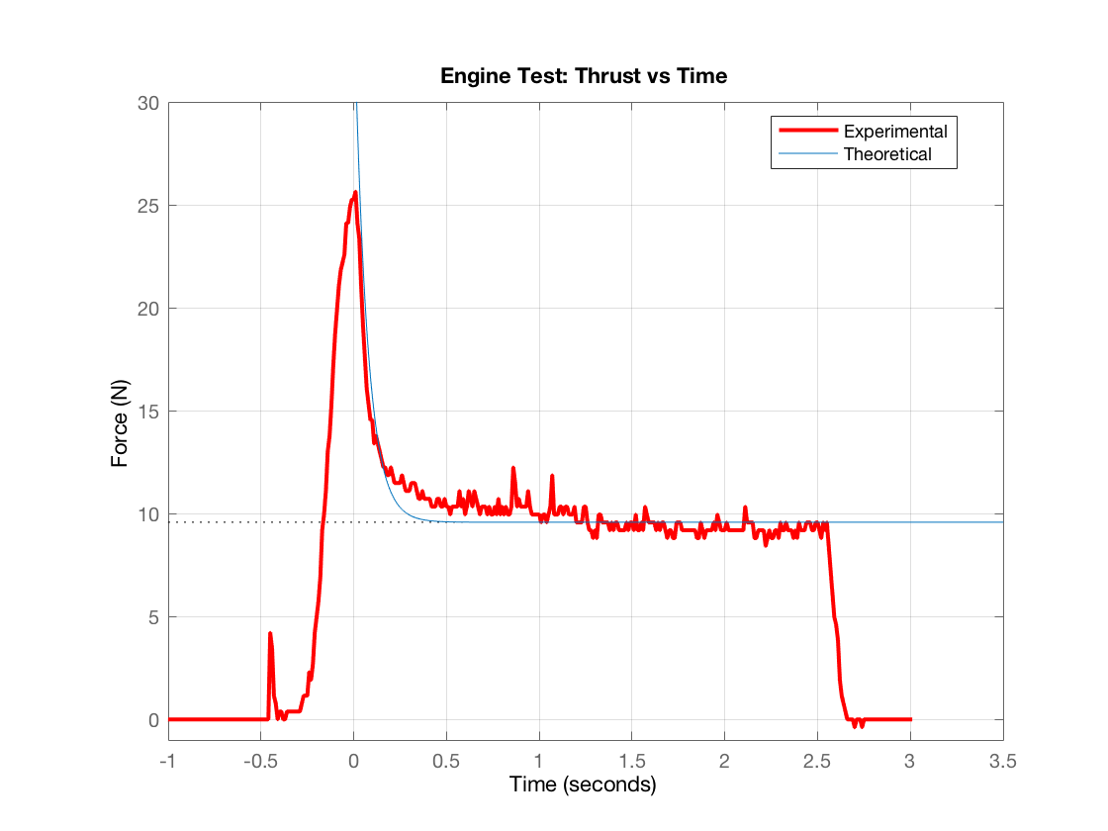

*Figure 4: Estes E-9 Experimental and Theoretical response curves*

The experimental data reaches a maximum thrust of 25.7 N before decreasing to a near-constant thrust of 9.6 N. A theoretical 1st order step response was found using the time constant of the system and compared on the plot above alongside the experimental data. As shown, the calculated results are similar to the data recorded by the load cell. Additionally, the response was compared to the standard thrust response given for an Estes E-9 engine, which is displayed in Figure 5 below.

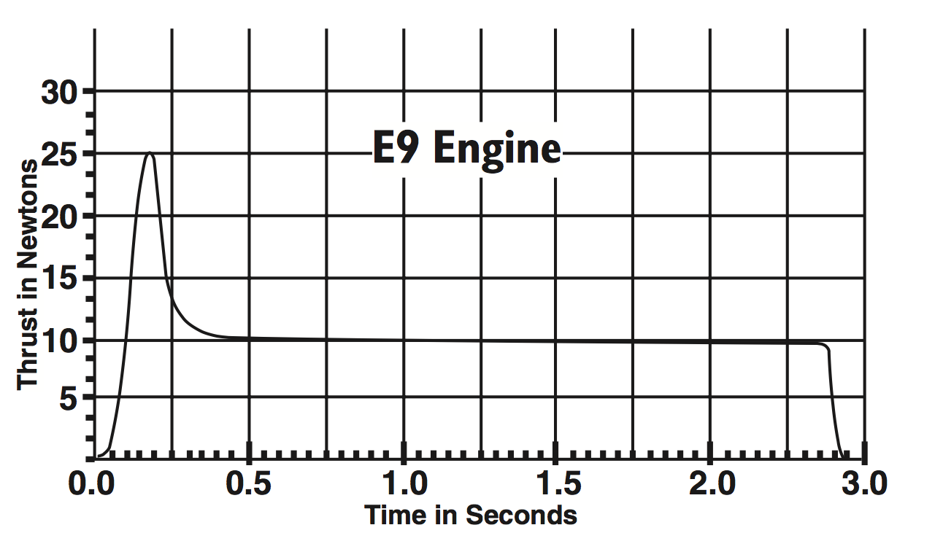

*Figure 5: Estes E-9 Engine Thrust Response*

The engine fires for 3 seconds and reaches a maximum thrust of about 25 N. The experimentally recorded data in Figure 4 gives a very similar thrust response to the expected engine system in Figure 5 shown above. These results ensure the team that data was captured accurately and effectively.

**Aero/Rocket Body**

The model displayed in Figure 6 is the single-stage rocket design modeled using OpenRocket software.

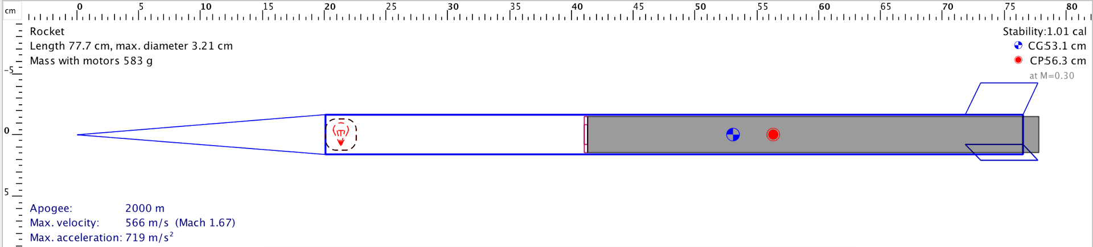

Figure 6: Conical Mk 1 Rocket Design

In designing the rocket, the primary goal is to achieve maximum altitude. This goal can be partitioned and simplified into many sub-goals, which include minimizing aerodynamic drag forces, ensuring rocket stability, maximizing the thrust to weight ratio, and maintaining a safe structural integrity. These sub-goals will drive the analyses that follow.

A number of constraints provide limits that dictate geometric ranges for the aerodynamic design. These can be categorized into material constraints, manufacturability, aerodynamic theory, competition rules, cost, and time.

A single-stage rocket is being designed and manufactured as a working prototype before building the two-stage rocket for the competition. This is being done in the hopes of correcting any fatal flaws in the design before committing more time and money into building the more complicated multistage design. Therefore, the following analysis is for a smaller single stage engine prototype, named “Conical Mk1”. A secondary goal for the Conical Mk1 is to design such that it can be used as the 2nd stage in the final two stage rocket. That way all that would be required for the final rocket is to design and build the booster stage that can be coupled to the Conical Mk 1.

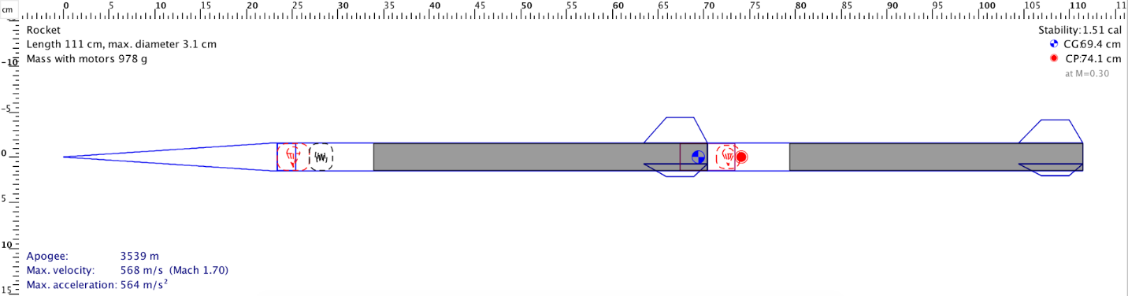

Figure 7: Multistage design that uses the Conical Mk 1 design as the second stage

Figure 7 shows the design for the second-stage rocket. This will be the final design the team pursues if the manufacturing and launch of the single-stage rocket is successful.

**Flight Path Overview**

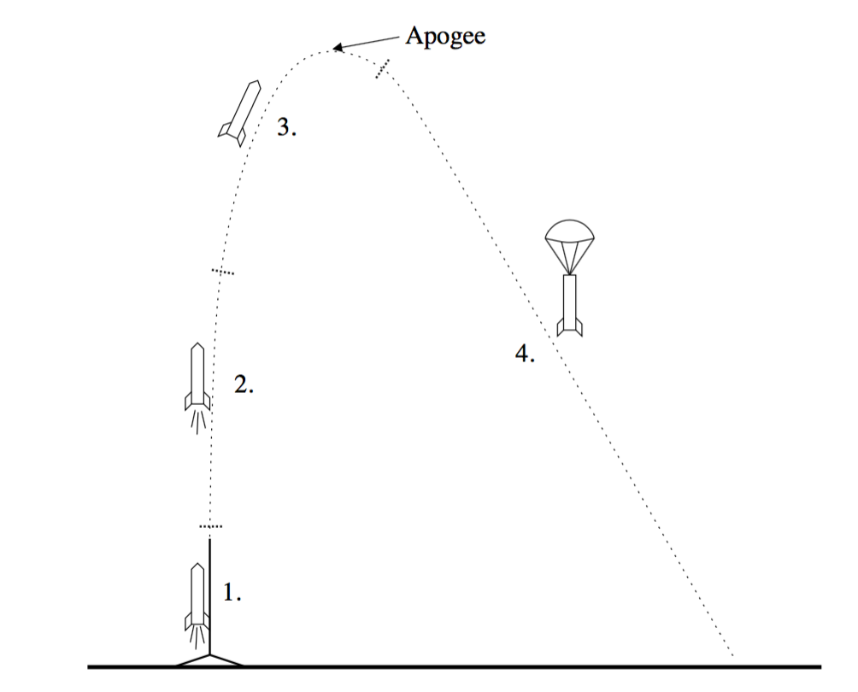

*Figure 8: Phases of a rocket flight. 1. Launch 2. Engine powered flight 3. Coasting 4. Parachute deployment*

A successful rocket flight can be categorized into four phases as shown in Figure 8. In phase 1, the engine is ignited and the rocket accelerates along a vertical guide. This is to keep it upright until the velocity is high enough for the fins to sufficiently stabilize the rocket. Our team is building our own launch pad system, and to simplify the manufacturing process we decided to attach lugs along the outside of the fuselage that will ride along a 6 ft. metal rod. The relative size of the lugs is small enough such that they can be neglected in the following aerodynamic analyses.

The 2nd phase of the flight occurs the moment the rocket is free from the launch guide. This being our first rocket build, we decided to purchase a H295-SS solid propellant rocket engine. Propellant is being burned at a near constant rate from the engine, and at this point it can be assumed that the engine is providing an average thrust of 273.3 N. This thrust was taken from the provided engine specification sheet, however in the near future we will be able to confirm this number using the static test fire rig. Also it may be advantageous to investigate liquid or hybrid engines in future rocket designs as they provide the ability to throttle thrust, which would provide a useful degree of control. It is at the end of the 2nd phase when the rocket has achieved its maximum velocity.

After the propellant has been used, the rocket enters the 3rd phase of flight which is where it coasts freely until gravity and drag forces decelerate the rocket to its apogee. It is shortly after this point when the ejection charge in the body pressurizes and pops off the nose cone of the rocket, which then releases the parachute.

**Minimizing Aerodynamic Drag Forces**

In ideal conditions with no cross wind, a perfectly aligned engine thrust vector, and a completely symmetrical body geometry, the axial drag equation would provide sufficient analysis.

Pressure drag occurs due to a pressure difference in the air in front and behind the rocket. This difference is caused by the air being forced to speed up around different cross sectional geometries of the rocket.

Where Cd is drag coefficient**,**  is fluid density, V is free stream velocity, and A is effective cross-sectional area. Cd is typically measured experimentally, and it is known that the nosecone geometry is the largest contributor to this value. Therefore we can utilize typical drag coefficients for nose cones displayed in Figure 9.

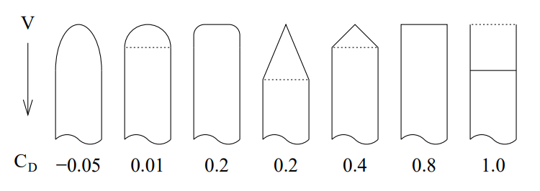

*Figure 9: Drag coefficient for nose cone geometries [4]*

If the rocket is assumed to be a perfectly conical nose cone attached to a uniform cylinder, a Cd of .2 can be used for calculations. Therefore, with a freestream velocity of 500 m/s and a cross sectional area of 1.06e-4 m, pressure drag is calculated to be 3.24 N.

Skin friction drag is caused by the viscous flow of air traveling axially along the rocket. Assuming a fully turbulent boundary layer, this friction drag can be found with the following equation.

Where Cf is the friction drag coefficient, which is a function of the Reynolds number and surface roughness of the rocket. is fluid density, V is free stream velocity, and is the surface area in contacted with the airflow.

Cf can be estimated using the following equation, assuming a fully turbulent flow.

Where R is the critical Reynolds number that is dependent on the surface roughness by:

Where Rs is surface roughness and L is the effective length of the rocket. The surface roughness for a finished and polished carbon fiber surface is about 0.5 micrometers [4]. The length of the rocket is 77.7 cm. This results in an R of 1.38e8, giving a Cf of .001972. With an assumed free stream velocity of about 500 m/s, and total rocket surface area of .00122 m^3, the estimated friction drag is about .368 N.

Since Cf is dependent to surface roughness, we need to make sure the carbon fiber surface has low impurities during the manufacturing process.

The total drag is the sum of these two forces, which is 3.60 N. The total force from gravity is about 4.478 N, therefore drag force is a significant factor in the total acceleration of the rocket.

Minimizing the aerodynamic drag was constantly a factor in designing the geometry of the rocket. Since both of these drag forces depend on cross-sectional and surface area, it was important to minimize the overall size of the rocket. Therefore it was beneficial to design the body of the rocket around the supplied engine to make length and diameter as small as possible.

In an ideal flight, axial drag would be the only consideration. However, wind caused instability is a significant cause of rocket failures and inefficiencies. An ideal rocket will translate all effective propulsive energy from the engine into vertical motion. The slightest deviation from a perfectly vertical angle of attack will convert some of that energy into lateral motion, thus lowering the rocket’s apogee altitude considerably.

**Ensuring rocket stability**

Rocket stability is the primary sub-goal as an unstable rocket will result in failure and even has the potential to be dangerous. Stability is dictated by the location of the center of gravity relative to the center of pressure of the rocket body.

Forces on the rocket can cause rotations about a point called the center of gravity. The center of gravity can be thought of as the location of the average weight of the rocket, which can be calculated with the following equation:

Here, d is the axial distance from the mass center of component to an arbitrary reference line, w is the weight of that component, and W is the total weight of the rocket assembly. In this case the reference line is the tip of the nose cone.

The center of pressure of the rocket is the point at which the sum of the aerodynamic force intersect. The resultant force through this point can cause a torque around the point that is the center of gravity. The larger the distance between these two points, the higher the force that is required to destabilize the rocket, thus lowering the change in angle of attack for a cross-wind. The center of pressure can be estimated in a similar way to the total center of gravity of the rocket.

Where d is the axial distance from the geometric center of the laterally projected area to an arbitrary reference line, is the laterally projected area of that component, and A is the total laterally projected area of the rocket assembly. In this case the reference line is the tip of the nose cone.

Table 4: Stability values

|  |  |  |  |
| --- | --- | --- | --- |
| Component | Mass [g] | CG distance [mm] | CP distance [mm] |
| Nose Cone | 8.64 | 100 | 80.7 |
| Body (including engine) | 46.7 | 444 | 444 |
| Fins | 15.5 | 731 | 719 |
| Total | **457** | **529** | **559** |

The distance between the center of pressure and center of gravity can be measured in calibers, where one caliber is equal to the diameter of the rocket. The conventional distance for optimal static stability for a rocket of our scale is about 1 caliber. This was a driving factor our design, as demonstrated in Table 4. Our rocket’s outer diameter is about 30 mm, which is equal to the difference between the total CG distance and the CP distance.

**Thrust to Weight**

The thrust value for the rocket is a given value from the supplied engine. In this analysis it is treated as a fixed variable. Therefore the only way to manipulate the thrust to weight ratio is to lower the overall mass of the rocket. This is why a diameter of 30 mm was chosen, as the engine diameter is about 29 mm which constrained the minimum size of the rocket. The engine also dictated the total length of the rocket, because the ideal length would be the exact length of the engine to minimize material. However, a space of about 100 cm^3 had to be allocated in front of the engine to hold electrical systems and the recovery device.

The choice of material was also important. Carbon fiber was chosen as it has a relatively low density paired with high strength and stiffness. This allowed us to minimize shell thickness to about 5 mm.

**Summary**

By the end of the semester the team designed and manufactured the first prototype of the static test fire. The first prototype can only handle smaller sized engines, so a second static test fire will be designed and manufactured as we progress to larger rockets and engines. The rocket body has been designed in solid works and will be manufactured in the near future. The main purpose for the first rocket is to test if the teams design approach is correct. If the rocket successfully launches, the team will follow a similar design approach for the final rocket. If not, the team will address the issue and attempt to design against the cause of failure. The engine has been chosen and is in our possession ready for use. The launch pad has been designed and parts have been manufactured, however the final assembly has not been completed. The field next to the lodges has been selected as the local launch site. The dimensions have been measured and is determined to be an adequate launch site. Charlie Nitschelm, the president of UNH SEDS, has received his launch certification, meaning he will be the one to launch the first rocket.

The first obstacle the team encountered was finding connections to the industry. This being the team's first year, finding someone with experience was essential to understanding where we are heading. This was resolved by attending a local launching event in Maine, where the team learned a lot. The next big obstacle was manufacturing. Manufacturing of our components has been put off much longer than expected. The team is scheduled to do more manufacturing in the Kingsbury shop in the near future. Lastly, managing the number of members in the SEDS club had proved to be challenging. This has been resolved by delegating team members to specific project groups and assigning leads as management.

**References**

**[1]** Apogee Components, I. (2017). *Model Rockets & How-To Rocketry Information*. [online] Apogeerockets.com. Available at: https://www.apogeerockets.com/ [Accessed 8 Dec. 2017].

**[2]** Richard Nakka's Experimental Rocketry Site. Accessed December 08, 2017. <https://www.nakka-rocketry.net/static.html>.

**[3]** Web.mit.edu. (2017). *14.2 The Rocket Equation*. [online] Available at: http://web.mit.edu/16.unified/www/SPRING/propulsion/notes/node103.html [Accessed 8 Dec. 2017].

**[4]** Hoerner, S., Fluid-dynamic drag, published by the author, 1965.

**[5]** Department of Defense Military Design Handbook (1990). Design of Aerodynamically Stabilized Free Rockets. MIL-HDBK-762(MI).[1]

**Appendix**

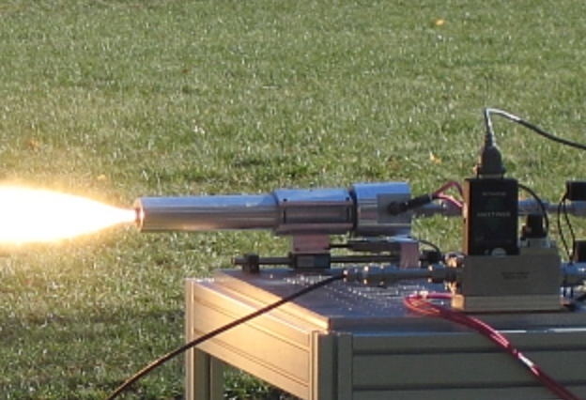

*Figure 10: horizontally oriented static test fire rig*

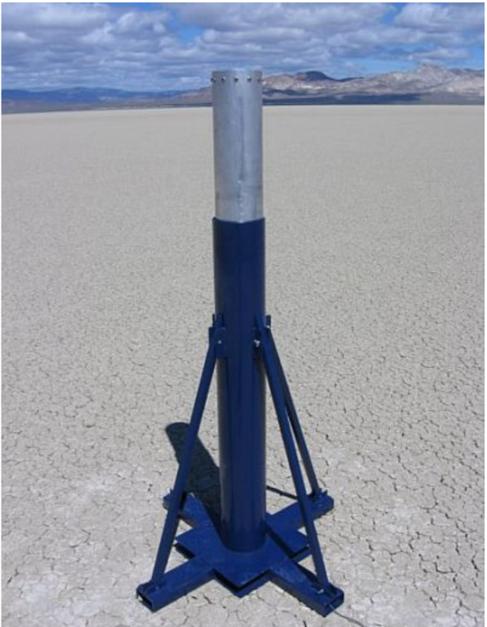

*Figure 11: vertically oriented static test fire system*

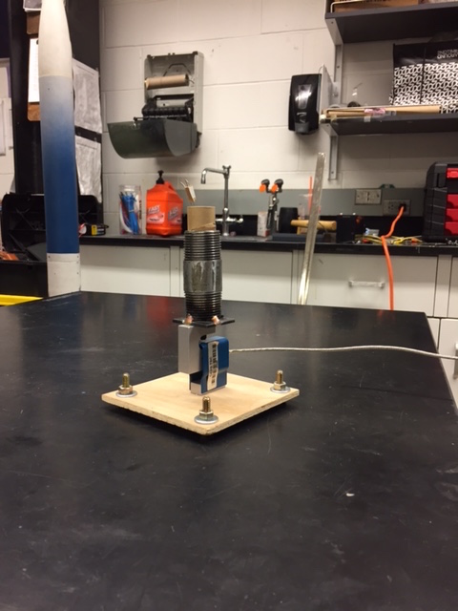

*Figure 12: Static test fire prototype*